Project Design Phase-II
Technology Stack (Architecture & Stack)

Date | 31 January 2025
Team ID | LTVIP2026TMIDS76616
Project Name | HematoVision – Advanced Blood Cell Classification Using Transfer Learning
Maximum Marks | 4 Marks

Technical Architecture:
HematoVision follows a three-layer architecture:
1️⃣ Presentation Layer
- Web interface built using HTML, CSS, and JavaScript.
- Allows lab technicians to upload blood smear images.
- Displays prediction results clearly.
2️⃣ Application Layer
- Backend developed using Python and Flask.
- Handles image upload and validation.
- Performs image preprocessing (resize, normalization).
- Sends image to trained MobileNetV2 model.
- Generates prediction results with confidence score.
3️⃣ Data Layer
- Stores trained model file (.h5).
- Stores uploaded images temporarily.
- Stores prediction logs (if required).

Reference: https://developer.ibm.com/patterns/ai-powered-backend-system-for-order-processing-during-pandemics/
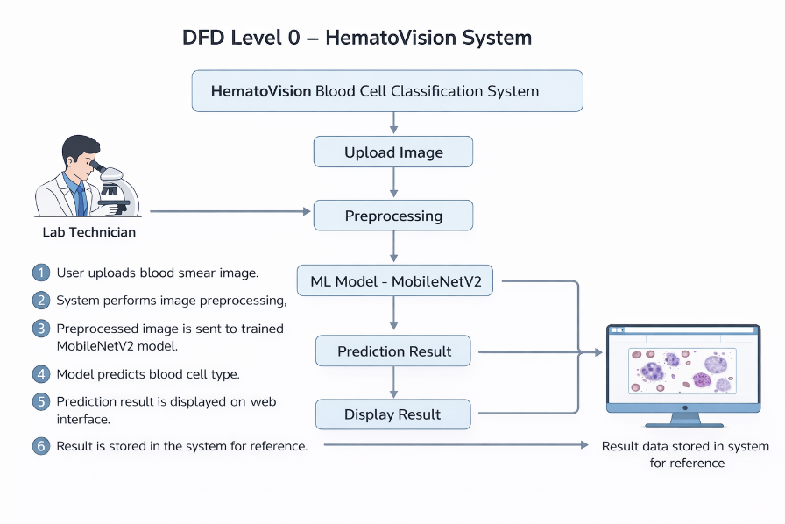
Guidelines:
Include all the processes (As an application logic / Technology Block)
Provide infrastructural demarcation (Local / Cloud)
Indicate external interfaces (third party API’s etc.)
Indicate Data Storage components / services
Indicate interface to machine learning models (if applicable)

Table-1 : Components & Technologies:
S.No | Component | Description | Technology
 | User Interface | Web interface for uploading images and viewing results | HTML, CSS, JavaScript
 | Application Logic-1 | Backend processing and routing | Python, Flask
 | Application Logic-2 |  | NumPy, OpenCV
  Image preprocessing logic
 | Application Logic-3 | Machine learning inference logic | TensorFlow / Keras
 | Database |  | SQLite / MySQL
  Store prediction results
 | Cloud Database | Database service (if deployed on cloud) | Render Database / PostgreSQL
 | File Storage | Store uploaded images and model files | Local File System
 | External API-1 | (Not required in this project)
  N/A
 | External API-2 | (Not required in this project)
  N/A
 | Machine Learning Model | Blood cell classification using transfer learning | MobileNetV2
 | Infrastructure (Server / Cloud) | Deployment environment | Local System / Render Cloud

Table-2: Application Characteristics:
S.No | Characteristics | Description | Technology
 | Open-Source Frameworks | Web and ML frameworks used | Flask, TensorFlow, Keras
 | Security Implementations | Basic input validation and secure file handling | Flask validation, HTTPS
 | Scalable Architecture | Can handle increasing image uploads | Cloud deployment (Render)
 | Availability | Accessible via web browser anytime | Cloud hosting
 | Performance |  | Optimized ML model
  Fast prediction within few seconds
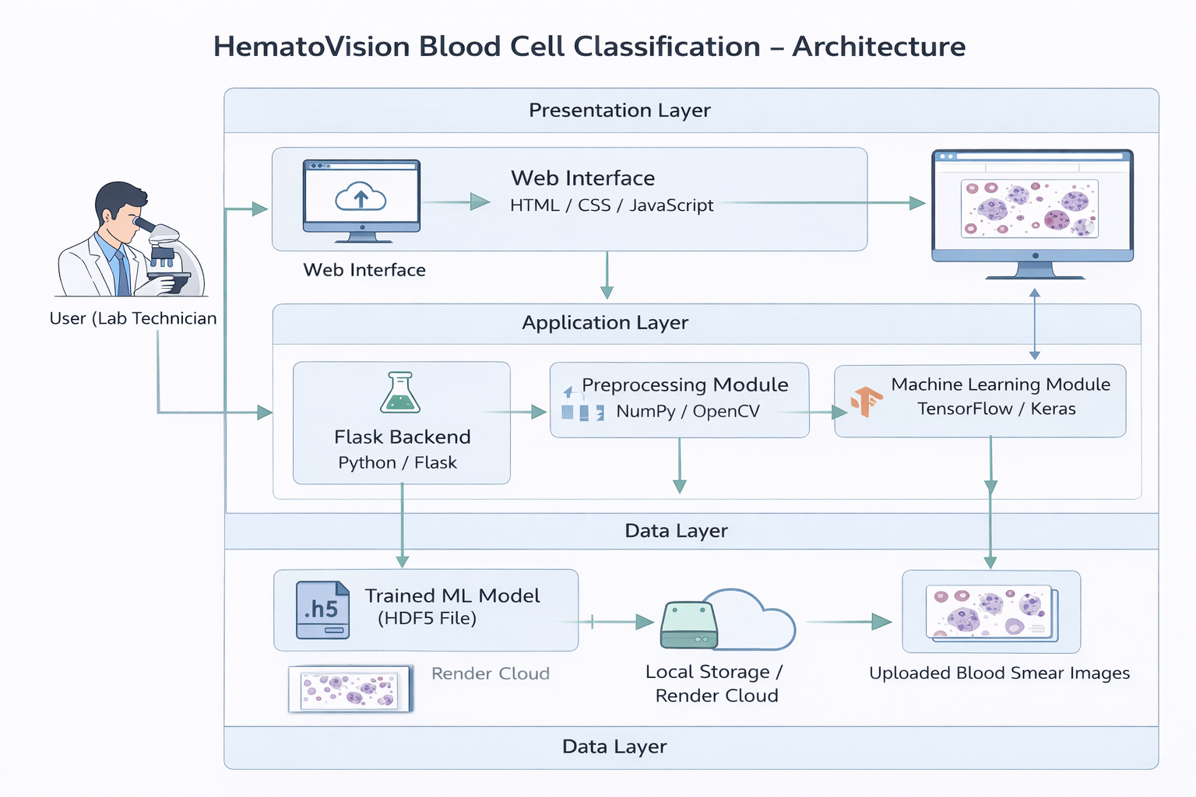

References:
https://c4model.com/
https://developer.ibm.com/patterns/online-order-processing-system-during-pandemic/
https://www.ibm.com/cloud/architecture
https://aws.amazon.com/architecture
https://medium.com/the-internal-startup/how-to-draw-useful-technical-architecture-diagrams-2d20c9fda90d

